Packaging a Vagrant box to create Base images

# IF using virtual Box, box packaging can also be done using vagrant package command line:

1. In powershell, run the following command:



--base specifies that a base box is being created out of a local VM

-- vagrant-win_dev_1453899120572_91072 specifies the name of VM in virtual Box as shown in picture below (selected VM):

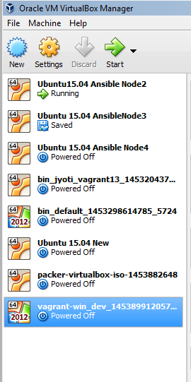

1. The vagrant package output is as following:



## Installation of base box on target machine: (Pre-requisite: make sure virtualization is enabled on the remote machine.)

1. Copy the *package.box* file to a folder(for example, D:\vagrantbox) on target machine
2. Make sure Vagrant is installed([www.vagrantup.com](http://www.vagrantup.com)) and also Virtualbox ( <https://www.virtualbox.org/wiki/Downloads>) is installed
3. In Powershell, cd to D:\vagrantbox folder
4. Run the following command:



* *Vagrant2012R2Jyoti* is the name given to new VM installation. You can change this name to anything of your choice
* *Package.box* is the base box we copied from original vagrant host

Output shall look like following: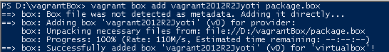

1. Create the vagrant file – create a new folder for vagrant





It shall output as following:



1. Finally, create the VM using vagrant up



It should initialize the VirtualBox and create the VM, the output should look like following:

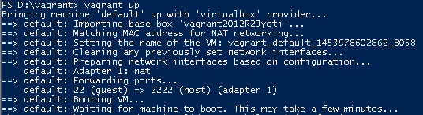

*Ref:* [*http://www.developer.com/net/virtualize-your-windows-development-environments-with-vagrant-packer-and-chocolatey-part-2.html*](http://www.developer.com/net/virtualize-your-windows-development-environments-with-vagrant-packer-and-chocolatey-part-2.html)

This method of packaging a vagrant box is applicable ONLY to virtual Box VMs

# Using Packer:

On a windows machine,

Install the Packer: <https://www.packer.io/downloads.html>

Unzip the zip and copy all the binaries (including .Exe files) into bin folder where Vagrant.exe is lying.

Copy the template.json into same location from folder where binaries were extracted